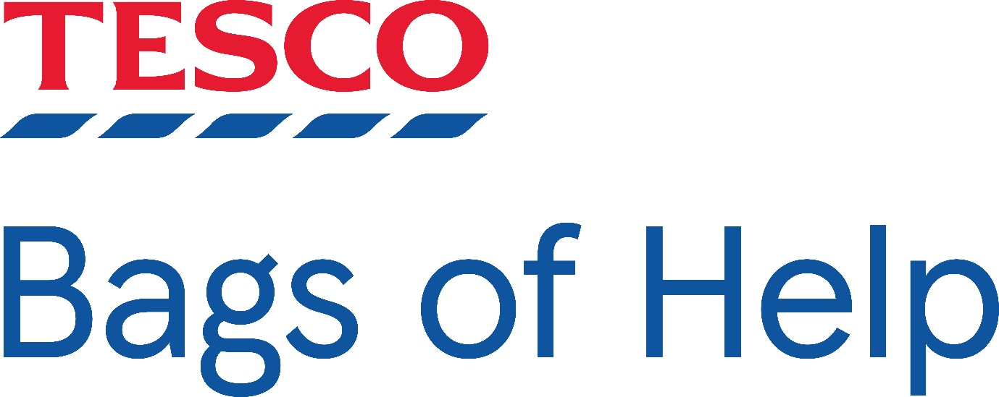

We have been selected as the charity of the month for March and April at Tesco Extra Holmbush and Tesco express Upper Shoreham RD.

Please request a disc and vote for us, we are raising money for Forest school and garden equipment.

