

info@southdownnursery.co.uk 01903814581 www.southdownnursery.co.uk
Summer 1st half of term

Welcome back, I hope you all had a wonderful Easter break. Thank you for all your kind donations of seeds, it was so lovely to be able to enjoy the garden and get it ready for the next few months. We would be very grateful if anyone has any established tomato plants we could add to the veg patch. Thank you to everyone who came to the Easter hunt, we raised a lovely £72. A huge heartfelt thanks to the events team and all of you who took part in the Bunny Hop – you raised a fantastic £475!!!! Amazing!!!! All the money will go towards resources for our lovely new outside kitchen and nature area.

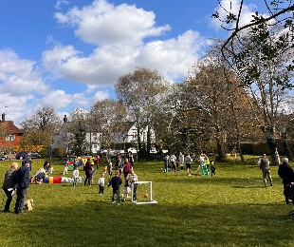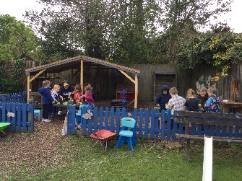

Fix it day and AGM Saturday 9th May 9.30-11.30am
This year we are combining the two! Please come along to hear about last year’s success’s and plans for the future and then join us with our termly tidy up.
We are urgently seeking new Trustee’s, it is a requirement by OFSTED that committee run settings have a certain amount of people on the committee, please join our fantastic team with helping me run the nursery - we meet for 1 and ½ hours every half term, roles include secretary, parent liaison, fundraising and finance, if you are interested please let me know and we can discuss further, or you could chat with my current trustees Houda, Nell (Ada’s Mummy) or Lucy (Henry’s Mummy)

Stay and play - Please join us this Monday 27th 9-10am to stay and play with your child and experience what they get up to at nursery, grandparents also welcome!

Parking
I feel like I am saying this a lot lately - please, please, please DO NOT PARK in our neighbours bay or across the driveway, even for a “‘couple of minutes”, it is causing distress and taking up a lot of my time.

Labelling items – Just a reminder to label everything your child brings to nursery – ESPECIALLY LUNCHBOXES, HATS AND WATER BOTTLES. Thank you

Website - Don’t forget we have a website which is updated with news, what’s coming up newsletters, info regarding term dates, events, long term planning and a section on school readiness.

Childrens parade – Please join us in the parade, we will bw mwwting by the big top in Fletchers Croft. There will be lots for the family to do afterwards and I’m told theres a lovely café too!

Tapestry – When your child starts with us I will activate the email link to be sent to you to join this online journal, please let me know if you haven’t received it, I use this system to share newsletters, planning and other information.

Fun in the sun at Southdown.
Clothing – We advise that children come in layers that are easy for them to put on and off, long sleeved cotton tops provide the best protection and comfort.
Suncream – Children need to come to nursery with it already on in the mornings. We have our own bottles of suncream, Nivea Sensitive Factor 50 to top the children up after lunch - in order to do this we require a £2 donation per family, (we won’t be able to use this on your child until you have consented and paid).
If you opt to use your own, please bring in a clearly named bottle, it will need to remain at nursery, we will store it in the medication cupboard, safely out of reach from the children - please do not leave it in their bags.
Sun hats - Please ensure your child has a clearly named sunhat. It is our policy that children wear hats in the sun.
Socks – if your child comes in crocs or sandals, please pop a spare pair of socks in as we do wear wellies in the morning due to the morning dew, We are seeking sock donations!

September register – Please let me know if you would like to change days or add sessions after the summer holidays, please do this in an email as I won’t remember if you tell me at the door! Also, please don’t forget to renew your 30 hour code by August 31st.

Summer Fair Saturday 20th of June 12pm-4pm
Please save the date for this, it is our main fundraiser of the year, as a charity we heavily rely on the funds raised for resources for the nursery.
WE NEED YOUR HELP!!! We are looking for people to join the fundraising team to help us plan , coordinate, and source for stalls, BBQ. bar and very importantly, the raffle. Please let me know if you are able to spend a couple of hours helping us.

Finally, are there any more parent questionnaires out there, I’ve only had 2 back! They are essential in helping us make improvements and we appreciate all comments,
Many thanks,
Lucy

Dates for the diary
Stay and play hour | Monday 27th April 9-10am
Fix it day and AGM | Saturday 9th May 9.30-11.30am
Children’s parade to open the Steyning Festival – we will be making shakers at nursery to bring along. | Saturday 23rd May 11.30am start – more details closer to the time.
Parents consultation | Tuesday 10th June 3.30pm- 5pm
Summer Fair | Saturday 20th June 12-4pm
Sports Day | Tuesday 30th June 9.15- 10am
Last Day of Term party and leavers ceremony | Wednesday July 15th  Party (For all children) 9.30am-11.30am  Leavers Ceremony 11.30 – 12pm  TERM ENDS FOR THE CHILDREN AT 12PM
1st Day of the Autumn term | Thursday 3rd September
Last Day of Autumn Term | Tuesday 15th December

