
www.southdownnursery.co.uk 01903814581 Info@southdownnursery.co.uk
Spring 1st Half Term 2026
I wish you all a very Happy New Year. Let’s hope that spring is just around the corner. 7 new families have joined us this term, a very big welcome to you and welcome back to our existing families.
Some children visited the Steyning Centre and did a little Christmas show for the lovely people at the Love to Move and Time to Chat group for older adults living with Dementia, MS and Parkinsons. We had a lovely end of term party with a special Christmas French Session.

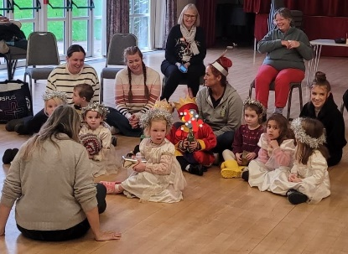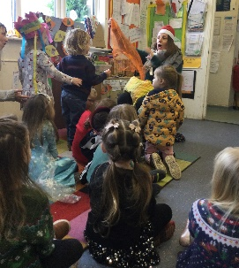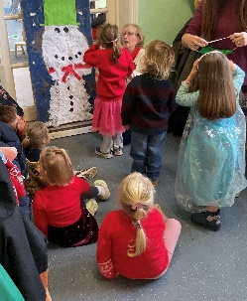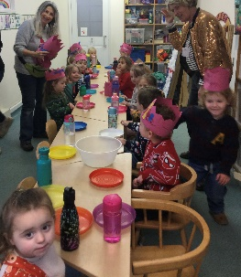

Early bird/late pick up – We have spaces available for this optional extra. Children are eligible from the term after they are 3yrs. The deadline for funding for this is Tuesday 14th of January – please use this service or lose it!
Website – Our website contains lots of useful information including policies, term dates, newsletters, termly planning and latest news, I will also post alerts such as closures due weather on the News section.
Dressing for the weather – Layers, warm coats, hats and gloves/mittens and spare socks for when they get soggy! I recommend extra thick socks. We do have spare wellies and waterproofs but if your child prefers items from home that is fine – please make sure everything is NAMED. Please could I also ask you to also name shoes, bags and lunch boxes and water bottles. Please send your child in shoes/boots that they are able to put on and take off independently.
Illness and sickness –. If your child is unwell, e.g. a temperature, sickness or diarrhoea or has required Calpol, they should remain at home. We are a small team and staff sickness leads to the disruption of sessions. I will send children home if they are unwell.
Medication at nursery - Please ensure medication is not left in your child’s bag and it is handed to a member of staff, and you have completed a medication record form. It is our policy that a child remains at home for at least the first 24 hours of starting a course of antibiotics, this is a precaution against a child having an adverse reaction.
Potty training - I wanted to share this website with you, it is full of top tips, guidance and advice when it comes to potty training. https://eric.org.uk/potty-training . We support all families when they start potty training, but we do ask that your child has had a few successful days at home first, this helps with the child’s confidence whilst at nursery and therefore a successful transition
Parking - PLEASE DO NOT park across our neighbour’s driveway, in the layby or in the middle of the road to drop off or pick up. The layby directly outside Nursery does not belong to us. There is plenty of parking in Fletchers Croft car park or Holland Rd which is just a short walk away.
Drop off and Pick up times - Session times are 9 -12pm and 12 –3pm. In order to run our sessions efficiently it is important you stick to these times, arriving outside of them disrupts the session.
If someone other than you is picking up your child, please let us know by phone (there may not be a member of staff in the office to pick up emails) and ensure they have the correct password. If we have not met them before we also need a description, knowing a password is not enough. Thank you for your understanding and support in this area.
Lunch boxes – Please ensure grapes, olives, sausages etc are cut lengthways to reduce the risk of choking, if they are not cut up, we will have to remove them. Thank you. *Please put snack in the fruit basket in the mornings.*

Interest table - We love it when your child brings along items they may have found or been given that are of any interest to them. It is a lovely opportunity for them to share an experience with both adults and peers. Items don’t necessarily need to be topical, we will be exploring and celebrating Chinese New Year from the last week of January.
Water bottles – In line with our healthy eating policy, oral good practice, and to prevent children preferring other people’s water bottles (!), please only put water in your child’s bottle, if juice is visible, we will replace with water. Thank you for your assistance with this.
Trustees – Southdown as a charity setting governed by a board of trustees made up of past and current parents and grandparents. We are coming to the end of the 2 year cycle and are looking to recruit new members. Do you have skills in management, finance, fundraising and event planning? We meet twice a term. Please contact me if you are interested and have any questions.
I know that there is a lot of info on here, so I thank you for bearing with me!
Remember I do have an open-door policy so feel free to contact me via phone or email at any time as it is not always possible for me to chat properly at drop off time.
Lucy and the team

Dates for your Diary 2025/26

Half Term | Mon 16th Feb - Fri 20th Feb
Fix it and play day  A lovely opportunity to help us maintain our garden and building alongside other Southdown families whilst your children play. | 28th Feb 9.30-11.30am
Parents consultation | Thursday 12th March –  3.45-5pm
Easter Hunt  All families welcome, coffee and cake stall | Monday 23rd 2pm
Last day of term | Thursday 26th March
Inset day | Monday 13th April
First day of Summer Term | Tuesday 14th April
Half Term | Monday 25th May – Friday 29th
Parents consultation | Monday 8th June 3.45-5pm
Summer Fayre | Saturday 20th June 12-4pm
Sports Day | Tuesday 30th June 9.15 – 10am
Last Day of Term | Wednesday 15th July

WhatsApp Group - This is a group run by parents for parent/carers.


