
Newsletter Autumn Term 1st Half 2025
A warm welcome back to you all, and especially to all our new families, it’s lovely to see so many of you! I hope you all had a wonderful break. Please can I ask you read this thoroughly, I appreciate that there is a lot of information but it is all important! I have printed this first one so that I know every family receives one, in the future the newsletter will be sent electronically and will be available on the website.
Online journal – We use Tapestry, as our online journal system, and we will also be using it as our messaging service and to inform you if your child has had a minor accident, replacing the old paper accident book.
You will have received an activation email from Tapestry, it may well have gone into your junk email, any problems, please ask me and I can resend. You will be required to download the Tapestry App, we will also use this as our messaging service
Observations will be available just before parents evening which is on Monday 17th of November. I will set the Privacy settings so that you will only be able to access your own child’s journal, sometimes there will be group photos, please can you let me know via email if you don’t want your child in group photos
Childcare choices website – This website has been helpfully renamed and relaunched, , please use the following website for your childcare and funding questions, I have had a look through it and I think it is easier to use Homepage | Best Start in Life
Parking – The bay outside nursery is not ours to park in and please, please don’t block the neighbour’s driveway by parking across it. There is plenty of parking at The Steyning center just a short walk away. Thank you in advance for your support with this.
Website – Please use our website to find information such as term dates, staff and their working days, what’s coming up, newsletters, planning and all of our policies.
Illness at nursery- We ask families to think carefully about the repercussions when ill children are sent to nursery, especially consider the infection of other children and staff. When a child is ill they require a level of care that we are unable to provide, the safest place for them is at home. A general rule of thumb is that if you have to question whether or not your child is well enough to come, they probably aren’t!
Children should not attend if they have a temperature that requires Calpol. If they have suffered from vomiting or diarrhea they must remain at home for 48 hours following the last outburst e.g. sick at 2pm on Sunday they can return to nursery on the Wednesday.
*Policy for childhood illness is on the website
Labeling items – Please label everything your child brings to nursery, that includes shoes, wellies, bags, clothes, water bottles and lunchboxes. I cannot stress how important it is for you to label your child’s lunch box, children have similar and the same boxes which can lead to confusion and for dietary/allergy reasons it is our duty to ensure children don’t eat the wrong foods! The same goes for water bottles, we encourage the children to be independent in selecting their drinks and it’s impossible for us to know everyone’s bottle.
Outside clothing – we are very much an outside nursery and spend the majority of our time out there, it is helpful for us and your child if they have their own wellies and waterproofs that can stay here with them.
Healthy Eating – Here at Southdown we promote Healthy Eating, this also includes healthy drinking, we serve water and milk throughout the day, we ask that your children have water only and no juice in their water bottles, you will be surprised that they do actually drink it if that is what is available. Thank you for your support in this area. No nuts - This is a reminder that we are a no nuts setting, we have a child who has a nut allergy so we are asking all parent/carers to be extra vigilant when making up packed lunches. To support Oral health and as advised by the Statutory Guidelines, we are asking you to not include Frubes or pouches in lunch boxes. Choking awareness - Food including fruit (especially grapes) and vegetables, cocktail sausages, cheese must be cut into batons.
Pick up and drop off times - Our drop off times are 9am and 12pm our pickups are 12pm, 2.45pm, 3pm 3.30pm, out of these times please be patient, the children are our priority and answering the door takes us away from them. It is especially important to keep to the pickup times to ensure the team can carry out their duties.
Early bird 8.30am and Late club until 3.30pm – We have availability in both these clubs and will funded entitled hours can be used towards it, we need an increase in numbers to make them sustainable, please let me know asap if you would like to add your child.
Change of details - It is really important that families update us of all changes including medical, family changes, new phone numbers, email addresses and home addresses.
Pre-existing accidents. - It is Statutory and our policy for parent/carers complete a form for any Pre-existing injuries that have occurred outside of nursery. Please let me know at the time of dropping your child off if you need a form.
Parent/carers WhatsApp group – This is a group run by parents for parents/carers. Please scan the code by the front door.
I think that’s it for now! Please don’t hesitate to contact me by email if you have any questions,
Lucy and the Southdown Team

Info@southdownnursery.co.uk 01903 814581 Gervays Hall, Jarvis Lane, BN443GL
Registered Charity Number 1081475 Company number 03823559 Ofsted 113701

Dates for your Diary
Half Term | Monday 27th – Friday 31st November
Garden and Fix it Day  Please join us in looking after the nursery and garden, all the family welcome, coffee and snacks provided. | Saturday 4th October 9.30am- 11.30am
Halloween Disco | Date TBC
Parents Evening | Monday 17th November
Nativity | Thursday 4th December 9.15am- 9.45am
Last Day of Term | Tuesday 16th December
Confirmation of 30 hour code deadline | December 31st  *These codes are valid for 12 weeks, as it’s a 14 week term we recommend you apply after the 1st of October.
First day of term for the children | Tuesday 7th January

________________________________________________

Note from the trustees:
Welcome (back) to Southdown!
A warm hello to all our new and returning families from the Southdown trustees! I’m Houda, one of the trustees — my son’s a Southdown graduate, and my youngest will be joining next year.
Southdown is a community nursery and charity, supported by an amazing team of parents, carers and grandparents. Trustees meet once a half term, and help things like events, fundraising, and maintenance — and we’d love you to get involved!
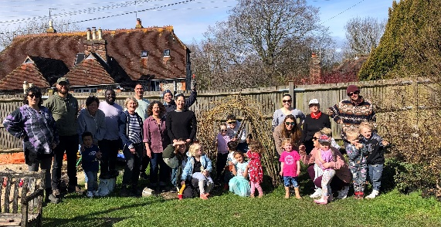

This term, you can join a Garden & Fix-It morning, help out at the Halloween party, or support the Christmas Raffle. Got DIY skills, finance experience or website know-how? We’re especially keen to hear from you. Talk to Lucy or email me at houda.davis@gmail.com
Looking forward to a fantastic term together! And don't forget to join the Southdown What's App group (QR Code below).
Houda, Alice, Chis, Lucy N, Lucy NJ, Nell and Will
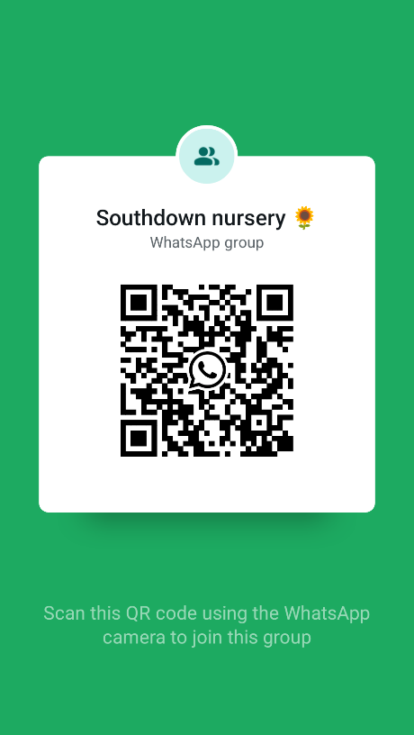

Dates for your Diary
Staff Meeting | Thursday 9th October
Half Term | 27th – Friday 31st
Halloween Disco | Monday 3rd
Staff Meeting | Tuesday 4th November
Tapestry ready  Parents Evening | Wednesday 12th November  Monday 17th November
Nativity | Thursday 4th December
Last Day of Term | Wednesday 16th December
First day of term | Monday 6th January (Inset)

