Come and join the Childrens parade!
On Saturday 26th May 2022 at 10.45am
Meeting at The Big Top Tent, Fletchers Croft
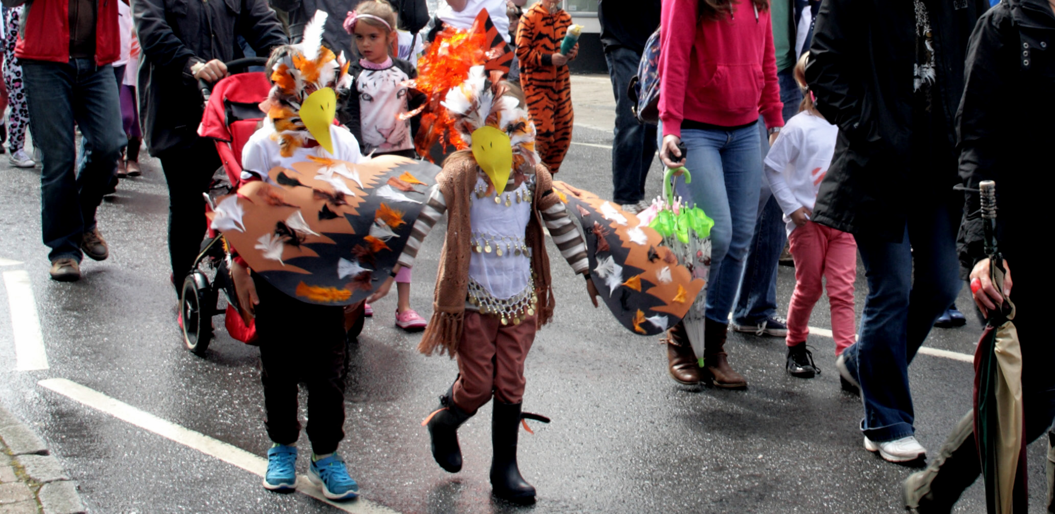

There is no better way to start the festival than with a fun gathering of our young families in the form of a Childrens Parade.
Please liaise with your child’s nursery or
school or just come along and join in the fun.
www.steyningfestival.co.uk
Check out the website for all childrens events!
Going on the Theme of ‘Keeping our Seas Clean to save our Oceans’ we would like the children to make musical instruments out of recycled bottles and boxes – anything that will make a noise! It would be great if the children could also make and attend in fancy dress as Sea Creatures again using recycled materials. Get the children involved – with their imaginations they have great ideas!
The Parade is open to children aged 0-8. and siblings welcome! They will need to be accompanied by an adult. The walk is short and around the Fletchers Croft area. (No Road Closures will be in place this year).

